The game begins with Oliver arriving home.  
The living room is empty, and no one seems to be home.

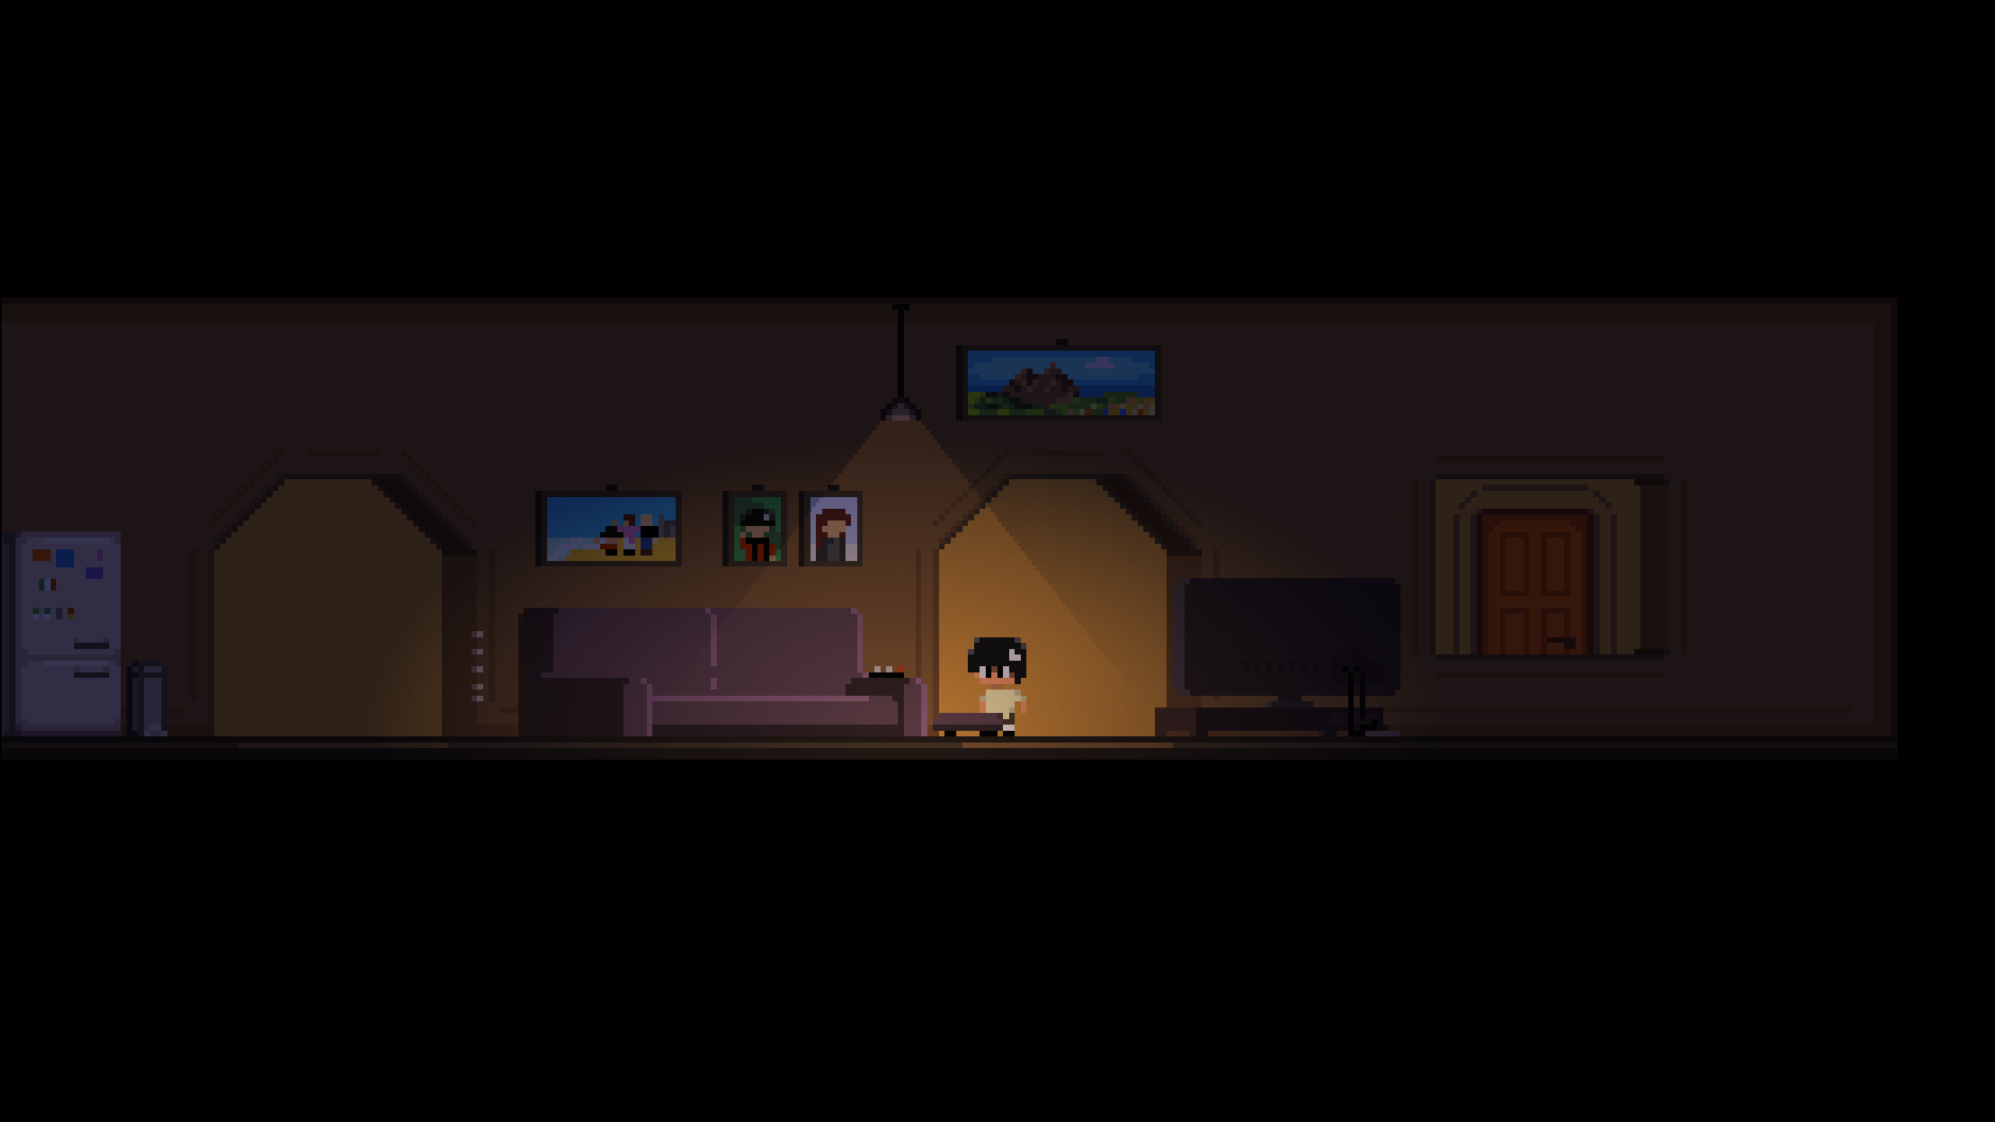

Oliver (the player) walks into their room.

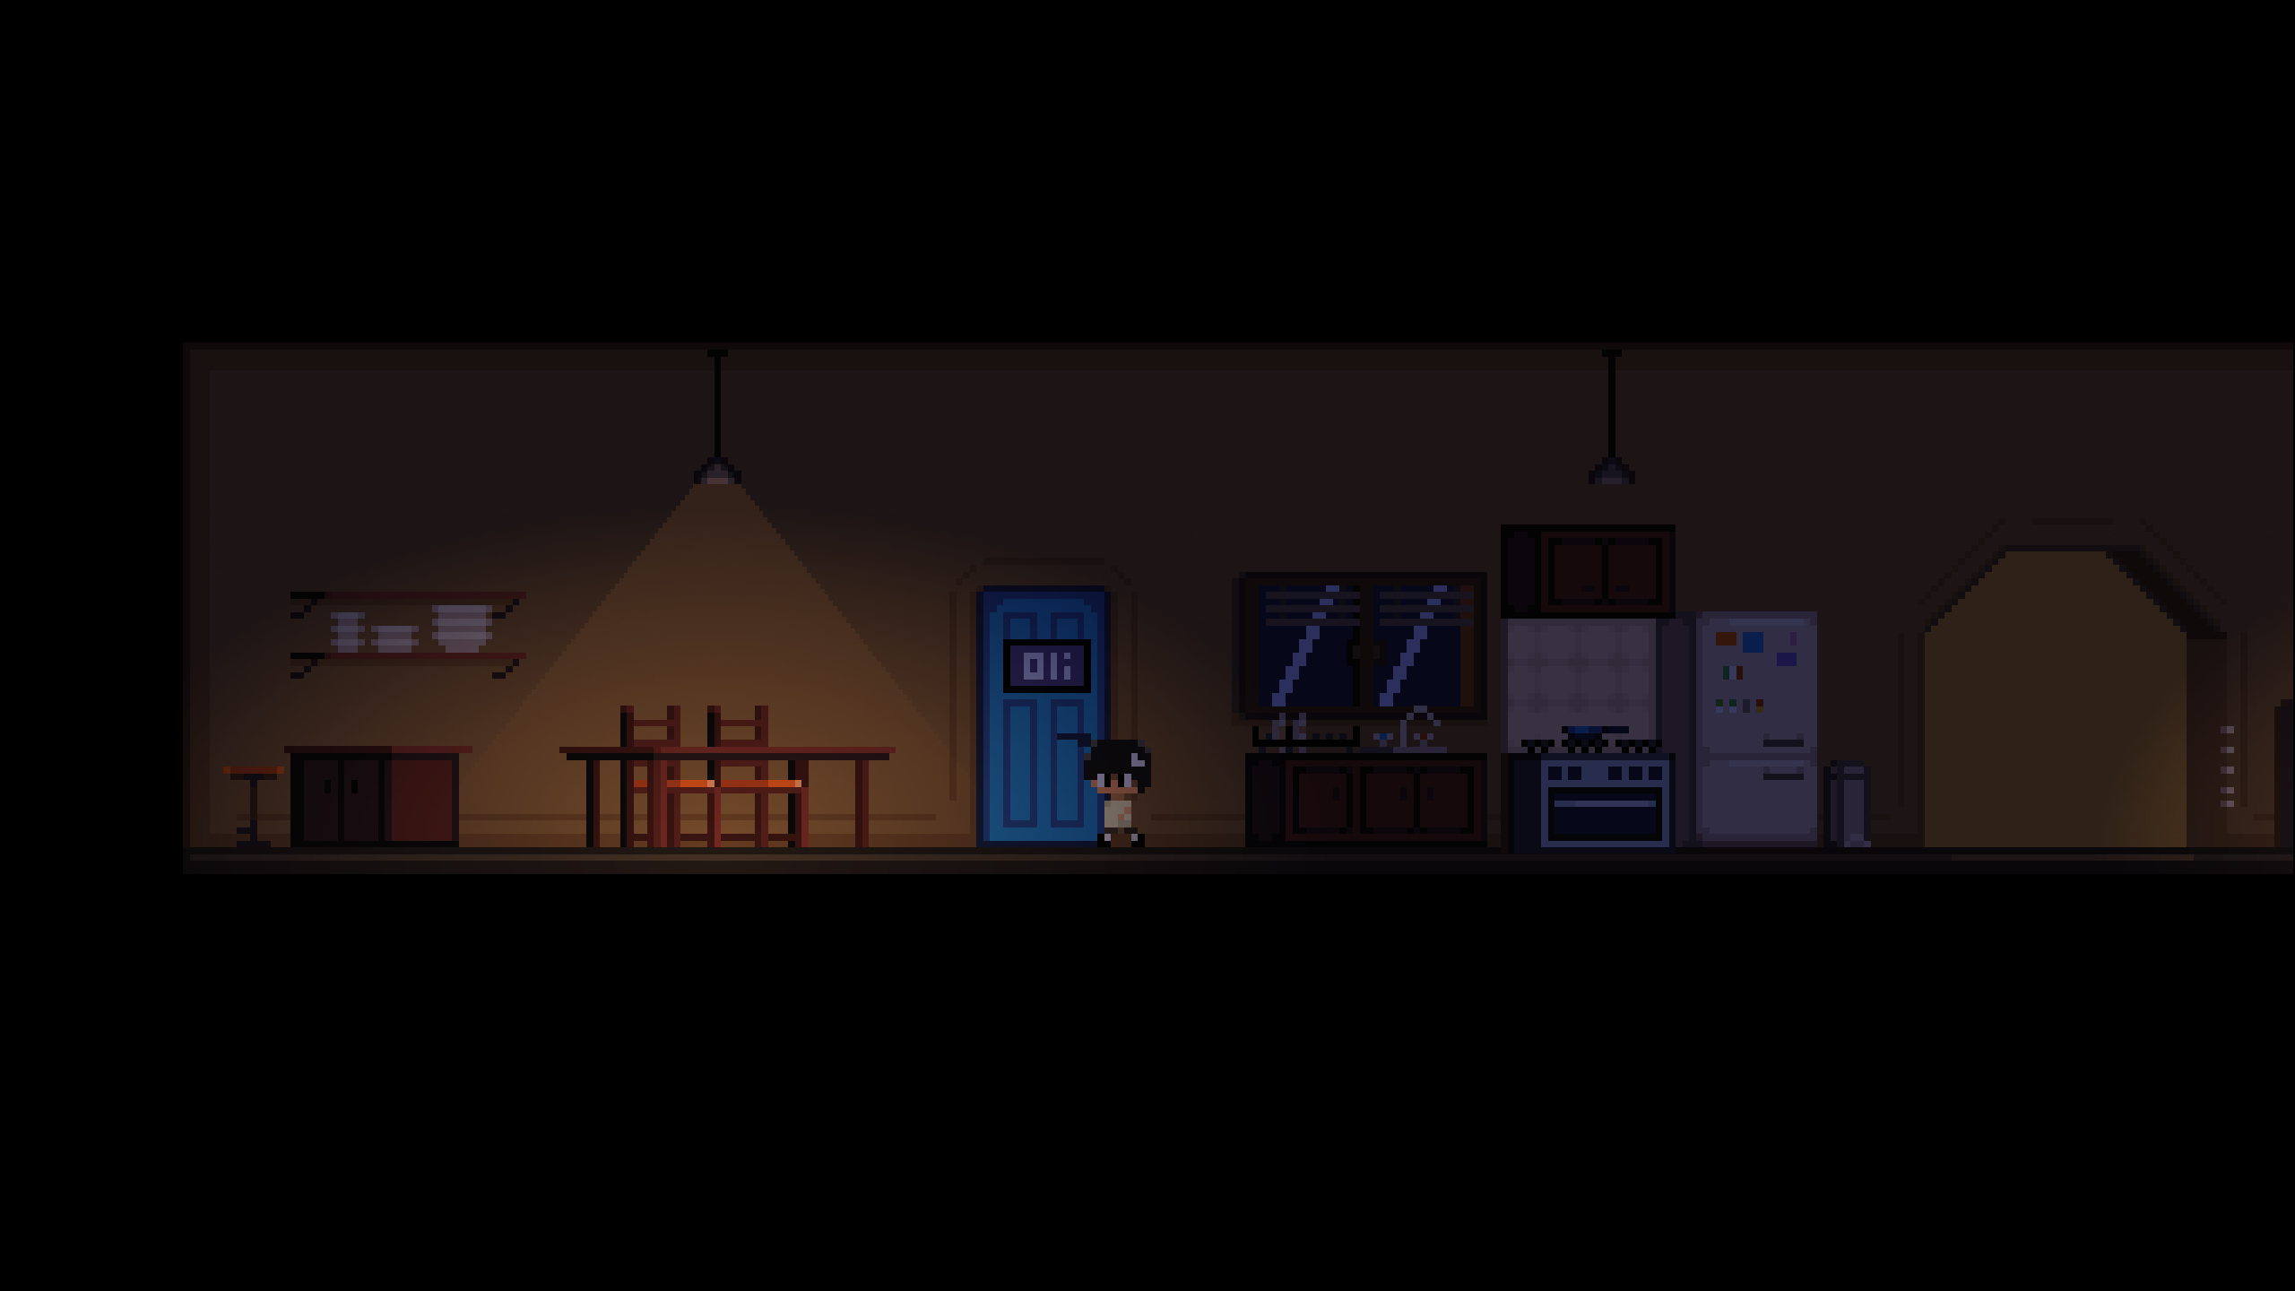

As they enter, the scene changes to a very surreal scene.  
Walking to the right reveals a tree, with someone sitting at it, drawing.

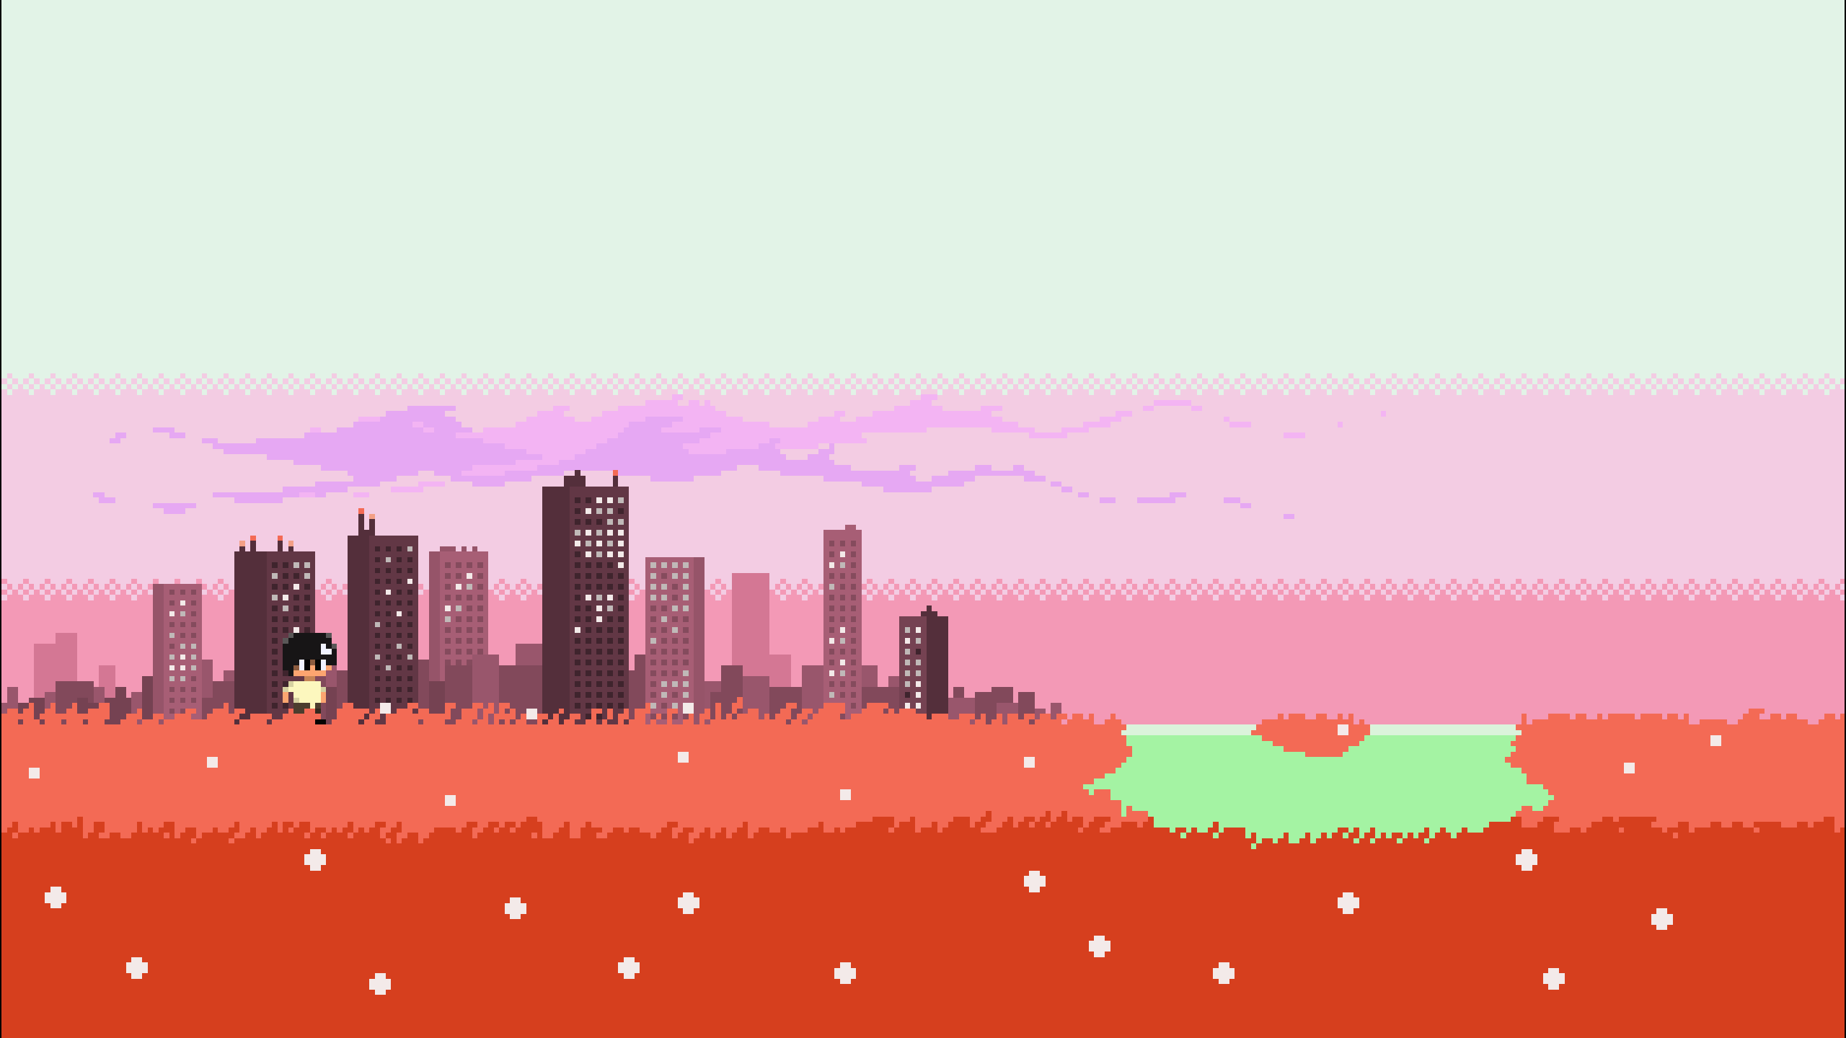

Sasha: Oli!  
Sasha waves at Oliver. (the player doesn’t know their name, please ignore their name being displayed here)

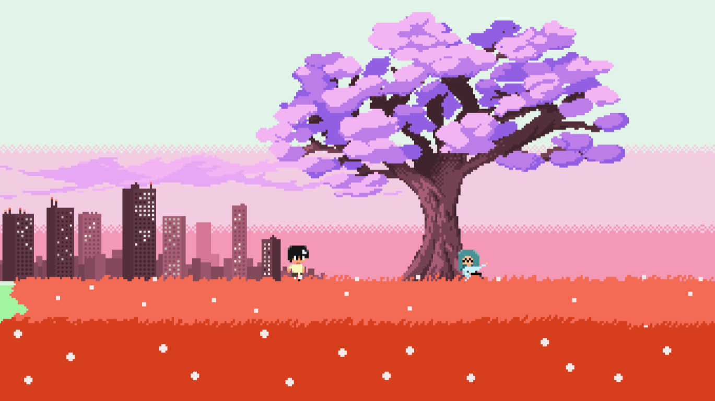

Oliver walks toward tree, and sits next to it.

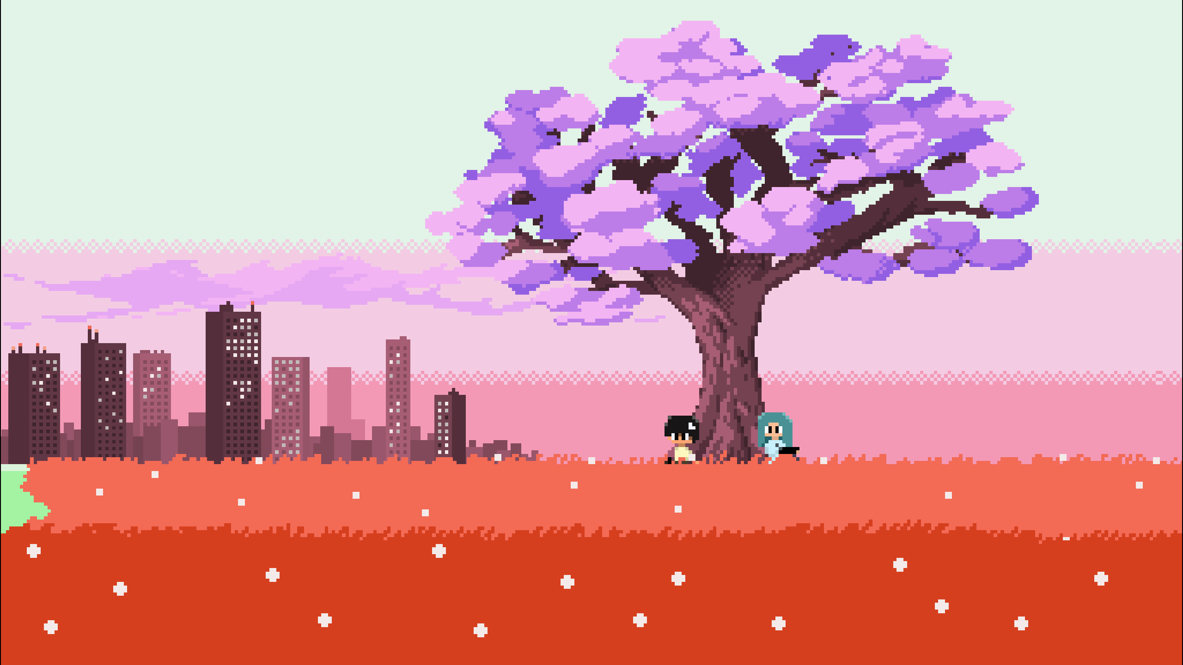

She looks to Oliver.

Sasha: Finally, you're on.  
Sasha: Look, I started drawing again.  
Sasha: Let me show you.  
Oliver: Soon, soon.  
Oliver: Just gimme a bit to chill first.  
Sasha: Ok ok.  
Sasha: Just tell me when.  
Oliver: I will.

Sasha gets back to drawing. Oliver looks to her for a second, before looking away.  
Sasha notices, looking at Oliver.

Sasha: ...

A small pause.  
She looks away, ahead.

Sasha: Your day been good?  
Oliver: Yeah, just school.  
Oliver: You?  
Sasha: It's been good.  
Sasha: Been thinking about dinner all day.  
Oliver: Mhh, why so?  
Sasha: Cause mum's making sushi tonight.  
Oliver: Mhh.

She looks towards him again.

Sasha: ...  
Sasha: What are you having for dinner? \*slow text\*  
Oliver: Um, I don't know.  
Oliver: I didn't really ask my dad.  
Sasha: Yeah...

A small pause.

Sasha: You, um...  
Sasha: You ok, Oli?  
Oliver: ...  
Oliver: I'm fine.  
Oliver: Just got a lot on my mind is all.  
Sasha: I don't blame you.  
Sasha: When do you start packing all your things?  
Oliver: Um.  
Oliver: I'm not sure.  
Oliver: I'm not sure when's too early or too close.  
Oliver: I've kinda been avoiding doing anything for it.  
Sasha: It's always good to be prepared.  
Oliver: You almost sound like my mum right now.

She look away again, ahead.

Sasha: Hey, sometimes, parents are right.  
Oliver: They wish.  
Sasha: Pff.

A small pause.  
Oliver looks toward her again, before looking away.

Oliver: ...  
Oliver: Um.

Sasha looks at him.

Sasha: Yeah?  
Oliver: Can I-

Loud knocking is heard, before the scene abruptly swaps to a bedroom, with Oliver sitting at a computer.

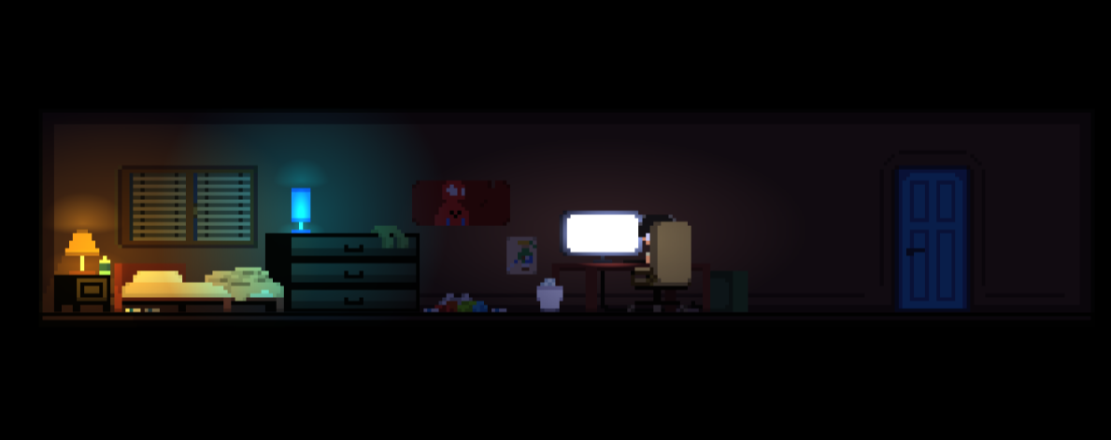  
He takes off his headphones.

Oliver: Coming!

The player walks toward the door, and opens the door.

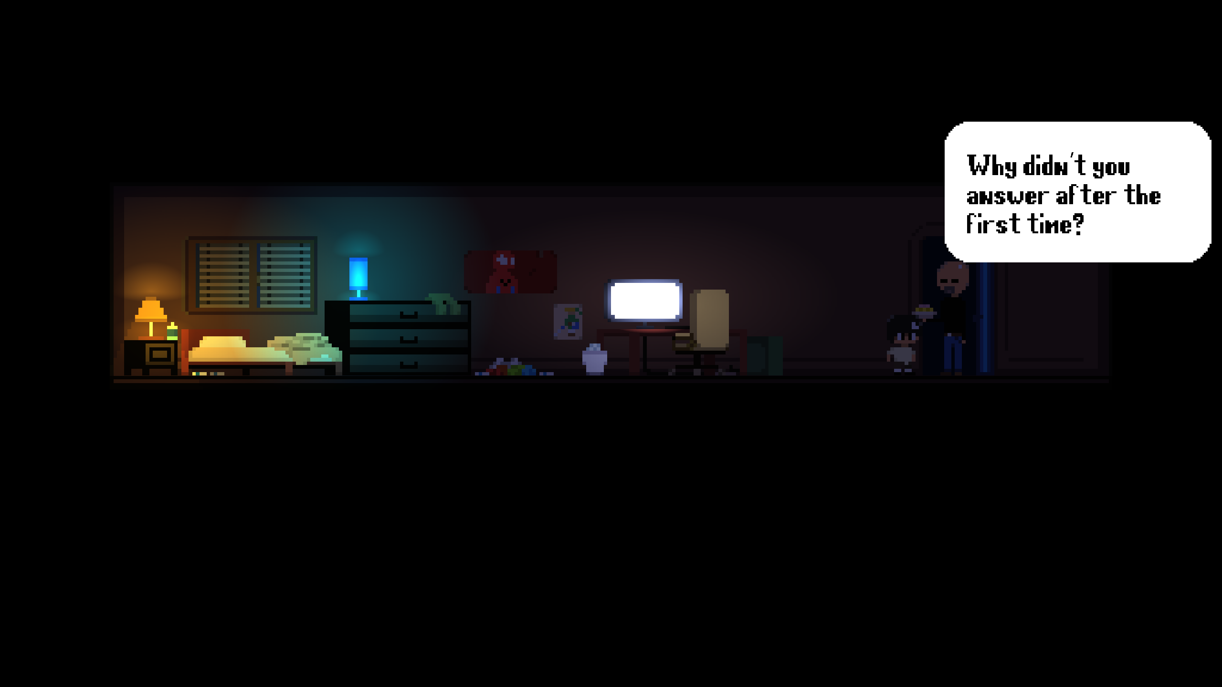

Papa: Why didn’t you answer after the first time?  
Oliver: I guess I didn’t hear it.

A small pause.

Papa: Who are you talking to?  
Oliver: Just a friend.  
Papa: Who is it?  
Oliver: ...  
Papa: ...

Another small pause.

Papa: I made you dinner.

The dad places the plate onto his desk, before walking around, observing the room.  
He stops at the clothes on the floor and looks down.

Papa: This mess...  
Papa: I shouldn’t even have to say anything.  
Oliver: ...  
Papa: ARE you going to say anything?  
Oliver: I’ll clean it later...  
Papa: Arrangia!

He storms toward the door, and slams the door behind him.  
Oliver (the player) jumps back on the computer, with the option to put away your clothes before doing so.  
(NOTE: Before the dad walks into the room, the player has the opportunity to put away the clothes. This doesn’t change the scene much, as the dad finds something else to complain about anyway, that being his son always being locked inside.)

Oliver: Hey, sorry, I'm back.  
Oliver: ...  
Oliver: You there?  
Oliver: ...

A small pause, with Oliver sighing.

Sasha: I'm back.  
Sasha: My dinner's ready, too.  
Oliver: Oh yeah, cool...

A small pause.

Sasha: Um.  
Sasha: You forgot to mute your mic.  
Sasha: I heard a little bit of that.  
Oliver: Oh.  
Sasha: It didn't sound good.  
Oliver: ... Yeah.  
Oliver: This is why I hate going out in the living room.  
Oliver: Never ends well.  
Sasha: I can only imagine.

A small pause.  
A soft song starts playing. Something a little warm, a little innocent, shy.

Oliver: Can I... come over tonight?  
Oliver: Please...  
Sasha: Of course, I'm sure my mum won't mind!  
Oliver: Sorry for asking.  
Sasha: Don't apologise. It's ok.  
Sasha: Come anytime. Just let me finish my sushi first.  
Oliver: Cool.

A small pause.

Oliver: I- um.  
Sasha: Mhh?  
Oliver: I never asked what kind of sushi you got.  
Sasha: Oh, um.  
Sasha: Just avocado.  
Oliver: Ewww.  
Sasha: Hey, avocado in sushi's great!  
Oliver: Avocado is like eating straight butter. It's awful.  
Sasha: You don't even like sushi.  
Oliver: Yeah, but that's a different matter.  
Sasha: Ok, what are YOU having then?  
Oliver: Just a classic. Spaghetti and tuna.  
Sasha: That's not a classic.  
Oliver: It's MY classic!  
Sasha: Ok, fine, but that's not a classic.  
Oliver: You don't know what you’re missing out on.  
Sasha: Ok. If you try sushi and avocado, I'll try spaghetti and tuna.  
Oliver: Mhh.‎  
Oliver: I'll think about it.

Oliver gets up, and eat his food very quickly.

Oliver: Ahhhhhhhhhhhh.  
Oliver: That hits the spot.

Oliver turns toward the door.

Oliver: Alright, I'm coming now.  
Sasha: ... Right now?  
Oliver: Yeah!  
Sasha: Did you just gulp your food down in one go?  
Oliver: Maybe.  
Sasha: You shouldn't do that, you know.  
Oliver: Well, I just did.  
Sasha: Let me know when you're outside.  
Oliver: Yup, see ya soon.

Oliver looks toward the window.

Oliver: Just wish I could sneak out the window, though.

Oliver turns back toward the door.

The player leaves back to the living room, to where his dad is sitting on the couch.

Papa: Where are you going?  
Oliver: Out.  
Papa: ...

A small pause.

Papa: Do whatever you want.

The player leaves back out the front door.